SECURECART FOR PRODUCT PURCHASE

System
📌 Overview
SecureCart is a secure and user-friendly web application designed for online product purchasing. It ensures safe transactions, smooth checkout, and efficient order management for users.

🚀 Features
- 🔐 Secure user authentication (Login/Signup)
- 🛍 Browse and search products
- 📦 Add to cart and manage items
- 💳 Secure checkout system
- 📊 Order management
- 👤 User profile management
- 🛡 Data protection and secure transactions

🏗 Tech Stack
Frontend:
- HTML, CSS, JavaScript
- (Optional: React.js)
Backend:
- Python (Django) / Node.js
Database:
- MySQL / SQLite
Other Tools:
- Git & GitHub
- Payment Gateway Integration (optional)

📂 Project Structure
SecureCart/
│── frontend/
│── backend/
│── database/
│── static/
│── templates/
│── README.md

⚙ Installation & Setup
1️⃣ Clone the Repository
git clone https://github.com/your-username/securecart.git
cd securecart
2️⃣ Backend Setup (Django Example)
pip install -r requirements.txt
python manage.py migrate
python manage.py runserver
3️⃣ Open in Browser
http://127.0.0.1:8000/

🔄 How It Works
- User registers and logs in
- Browses products
- Adds items to cart
- Proceeds to checkout
- Makes secure payment
- Order is placed successfully

🔐 Security Features
- Password hashing
- Secure sessions
- Input validation
- Protection against common attacks

SCREENSHOTS
HOMEPAGE
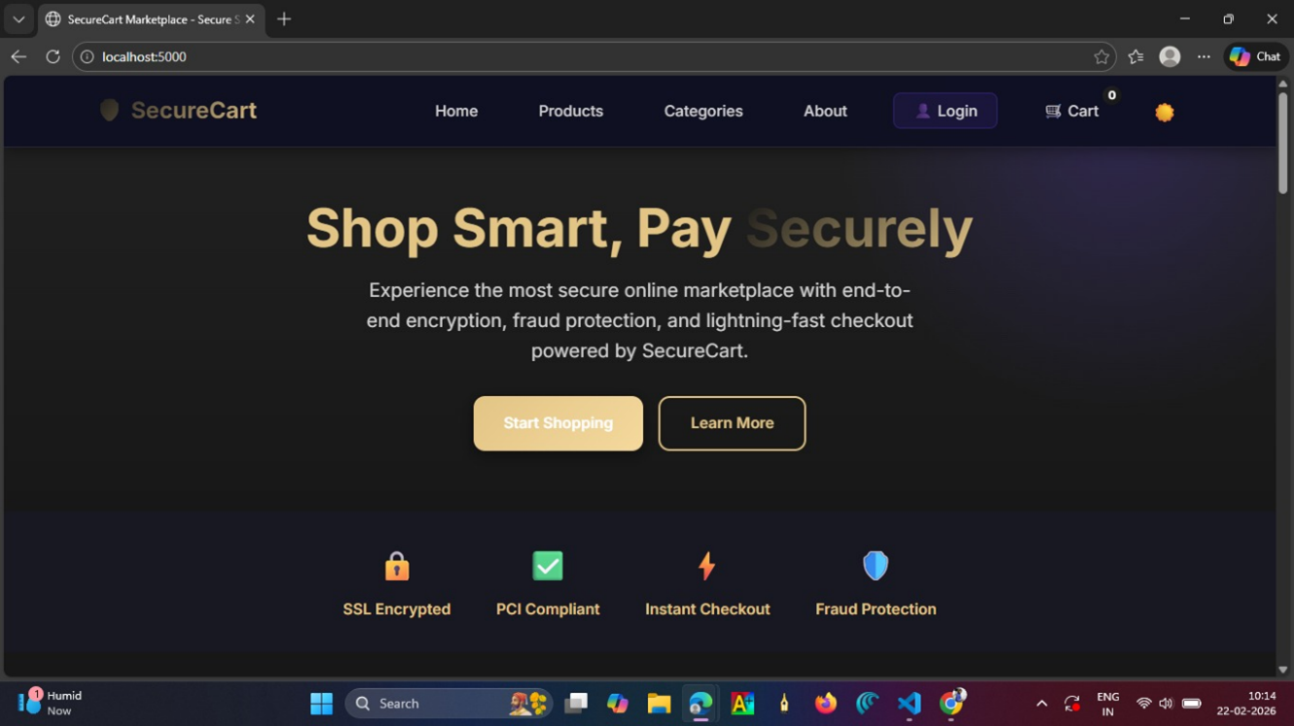
PRODUCT PAGE
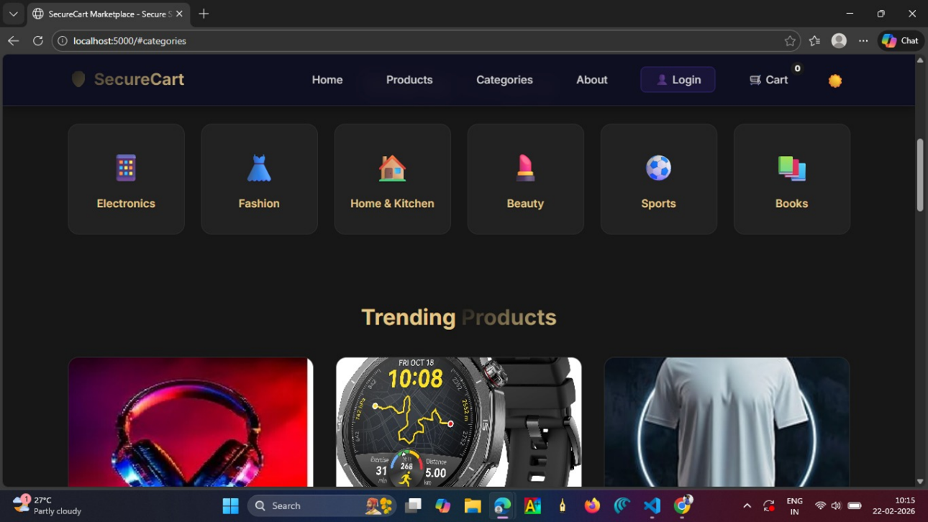
CART PAGE
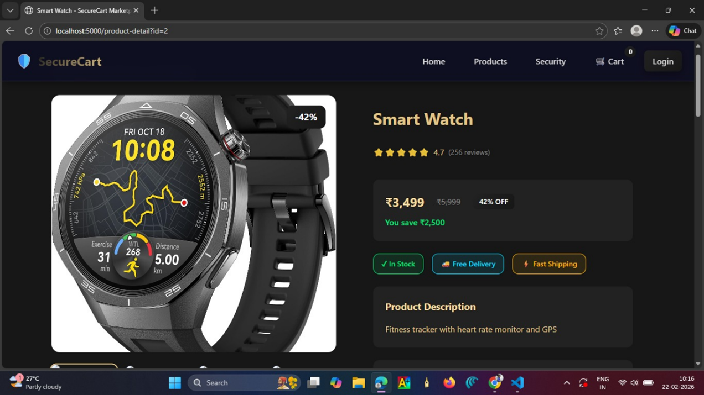
PAYMENT PAGE
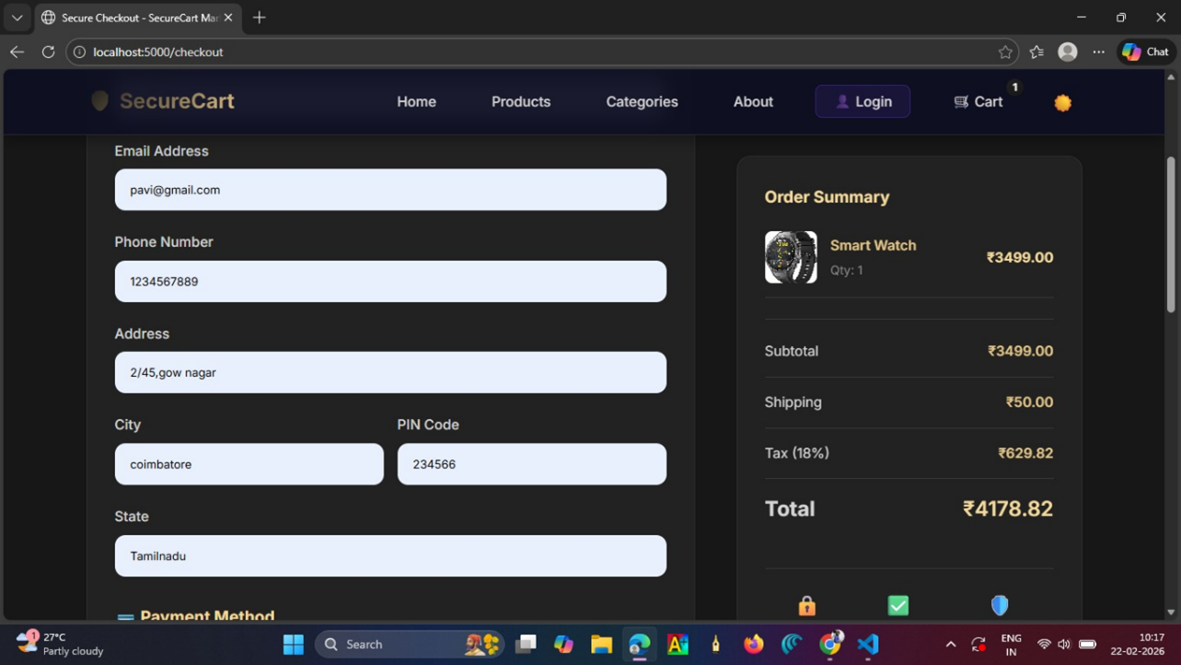
OVERVIEW PAGE
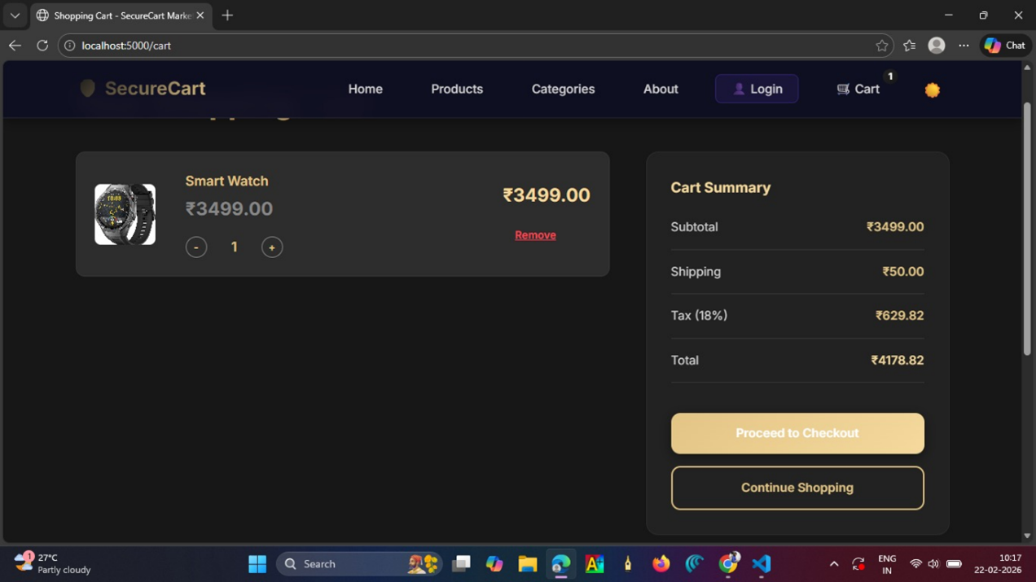

🎯 Future Enhancements
- Online payment integration
- AI-based product recommendations
- Mobile app version
- Admin dashboard

👩‍💻 Author
Pavithra Devi
BCA Student – KG College of Arts and Science

📜 License
This project is for educational purposes.

